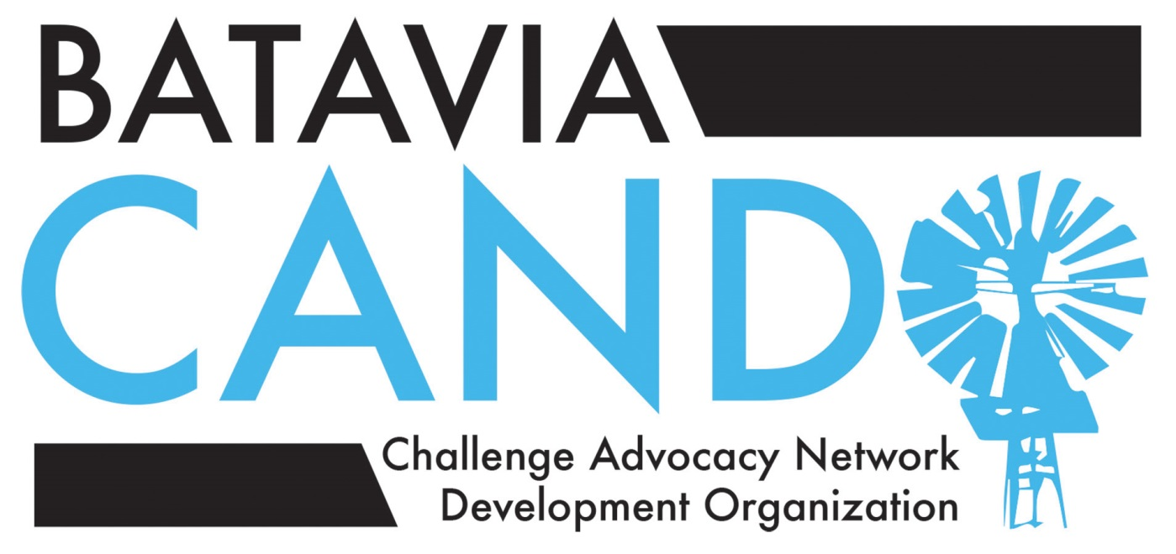
Notes on development of vision statement and
guiding philosophy for BPS101 Gifted Services
“Vision” Work Group, April 20, 2015
Members: Dr. Brad Newkirk, BPS101 Chief Academic officer
Dr. Susan Sokolinski, third grade teacher, AGS
Mrs. Laurie Fiorenza, Vice-principal, Curriculum and Instruction, RMS
Mrs. Jennifer Hix, divisional coordinator, RMS
Nikki Rousseau, parent (LWS, RMS) and CANDO LWS School Liaison
Jodie Pufundt, parent (RMS) and CANDO Secretary
Deb Grizzell, parent (Da Vinci Academy, LWS, RMS, BHS) and CANDO Chair
Christy Magerkurth, parent (Da Vinci Academy) and CANDO Advocacy Chair
Jessica Kelly, parent (AGS, RMS) and CANDO AGS School Liaison

Discussion points:

1. Proposed meeting plan from Dr. Brad Newkirk, BPS Chief Academic Officer
Detailed in a shared Google doc for the Vision Work Group members, including the following stages:
- Program evaluation
- Program Improvement
- Action Plan

2. Vision Statement and supporting goals suggested by CANDO Vision Work Group members:

CANDO-proposed Vision Statement and Accompanying Goals
Batavia Public School’s Gifted Services will challenge students to reach their full potential and prepare them to contribute to a complex global society by providing an environment of excellence that meets the distinct academic, social and emotional needs of gifted and high ability learners.

To achieve this vision, BPS Gifted Services has developed supporting goals that align with the District’s strategic goals. Progress can be monitored using the same measures and indicators identified in the District’s strategic plan.
Strategic Goal One: Student Learning
Ensure maximum development, growth, and achievement for all students
BPS Gifted Services Supporting Goals:
- Ensure that high-ability and gifted learners within the District achieve a full year’s worth of academic growth each year.
- Ensure that twice-exceptional students receive appropriately challenging services and support to enable growth and achievement of this sub-group.
Strategic Goal Two: Learning Environment
Provide a productive, safe, and supportive learning environment
BPS Gifted Services Supporting Goals:
- Provide appropriate support for the unique social and emotional needs of gifted and high ability learners.
- Provide opportunity for individual and collaborative learning experiences at an appropriate level of depth and rigor for gifted and high ability students.

Strategic Goal Three: Quality Staff
Cultivate a positive and productive working environment that attracts, develops and retains high quality staff.
BPS Gifted Services Supporting Goals:
- Ensure that professional development opportunities addressing differentiation for all students and the unique academic, social and emotional characteristics of gifted learners are offered and utilized.
- Ensure that appropriate staffing, materials and other resources are available to enable staff to differentiate instruction in an effective manner.
- Encourage collaboration across grade levels and across the District to identify best practices in differentiation, minimize duplication of effort, and celebrate successful staff members who can serve as mentors to other staff.

Strategic Goal Four: Partners in Achievement
Engage families and the community as vital partners in the education process
BPS Gifted Services Supporting Goals:
- Provide transparent information on the identification of and services for high ability and gifted students at all levels of the District through a comprehensive Gifted Handbook that is updated regularly.
- Ensure student successes in academics are celebrated and communicated regularly to highlight the District’s commitment to and pride in academic achievement.
- Encourage staff to welcome parent or community involvement in supporting differentiation and activities.

Strategic Goal Five: Resource Responsibility
Demonstrate effective and efficient business operations and ensure excellent stewardship of public resources
BOS Gifted Services Supporting Goals:
- Provide data and updates to the District Administration and School Board highlighting the value of policies and programs successfully supporting high-ability and gifted students.

…

Discussion of CANDO’s proposed vision statement centered around the values CANDO members felt important to convey in this introductory statement, as the vision statement will guide development of services and influence decision-making for gifted and high-ability students: 1) that the “whole child” be considered, including children’s emotional and social development, not just academic work; 2) that the vision statement would be inclusive of the whole population of gifted and high-ability students, including twice-exceptional students; 3) that the vision statement would reflect the “culture of excellence” Batavia seeks to cultivate in its schools.

There was lengthy discussion about the “culture of excellence” ideal. Work group members talked about the need to celebrate academic achievement and recognition of academic accomplishment, within the classroom and as a whole community in BPS. All members agreed that BPS has made tremendous progress in this area, and special thanks go to Sue Gillerlain, Director of Communications for BPS 101 for her work in fostering this type of climate in BPS.

- Work group members felt teachers should work in an environment that supports and promotes differentiated instruction for students, and that teachers should receive targeted professional development that will equip them to meet the different learning needs within their classrooms.

- CANDO suggested teachers and students would benefit from regularly-scheduled meetings for gifted cluster teachers at the elementary and middle schools across the BPS, to share “what works” and foster collaboration and reduce teacher work load.

- The “culture of excellence” would include not just “more work” for gifted and high-ability students, but enriched and/or accelerated/compacted learning opportunities when students’ show this learning ability/potential; and would foster motivation for academic achievement for all BPS learners.

3. Next steps for the Vision/Philosophy of Gifted Services Work Group:
- Report on progress at the May 11 Gifted Committee meeting
- Set another meeting date for this group before the end of the 2014-15 school year (May)
- Address the following points in upcoming discussions:
- Clear definitions of terms (i.e. flexible grouping, differentiation, etc.)
- Equity in service delivery—“giving kids what they need, when they need it, across the district”
- Partnerships with parents and teachers
- Consistency across levels of education in the district and in transitions between levels (i.e. elementary to middle school)
- Best practices in instruction
- Professional development
- Articulation
- Identification procedures
- Motivation—further work to establish a “culture of excellence”
- Addressing the unique social and emotional needs of gifted and high-ability students
- Special needs and considerations for twice-exceptional learners
Notes from this work group meeting will circulate to all work group members for review before the May 11, 1-2:30 Gifted Committee meeting.

Strategic Goal Three: Quality Staff
Cultivate a positive and productive working environment that attracts, develops and retains high quality staff.
BPS Gifted Services Supporting Goals:
- Ensure that professional development opportunities addressing differentiation for all students and the unique academic, social and emotional characteristics of gifted learners are offered and utilized.
- Ensure that appropriate staffing, materials and other resources are available to enable staff to differentiate instruction in an effective manner.
- Encourage collaboration across grade levels and across the District to identify best practices in differentiation, minimize duplication of effort, and celebrate successful staff members who can serve as mentors to other staff.

Strategic Goal Four: Partners in Achievement
Engage families and the community as vital partners in the education process
BPS Gifted Services Supporting Goals:
- Provide transparent information on the identification of and services for high ability and gifted students at all levels of the District through a comprehensive Gifted Handbook that is updated regularly.
- Ensure student successes in academics are celebrated and communicated regularly to highlight the District’s commitment to and pride in academic achievement.
- Encourage staff to welcome parent or community involvement in supporting differentiation and activities.

Strategic Goal Five: Resource Responsibility
Demonstrate effective and efficient business operations and ensure excellent stewardship of public resources
BOS Gifted Services Supporting Goals:
- Provide data and updates to the District Administration and School Board highlighting the value of policies and programs successfully supporting high-ability and gifted students.

The above vision statement and list of accompanying goals was developed by surveying the vision statements and program philosophies for gifted services programs in other school districts in Illinois and throughout the United States. CANDO’s Work Group members collaborated on the wording of the resulting vision statement. It was important to the CANDO group that the vision statement embodied the following principles:

