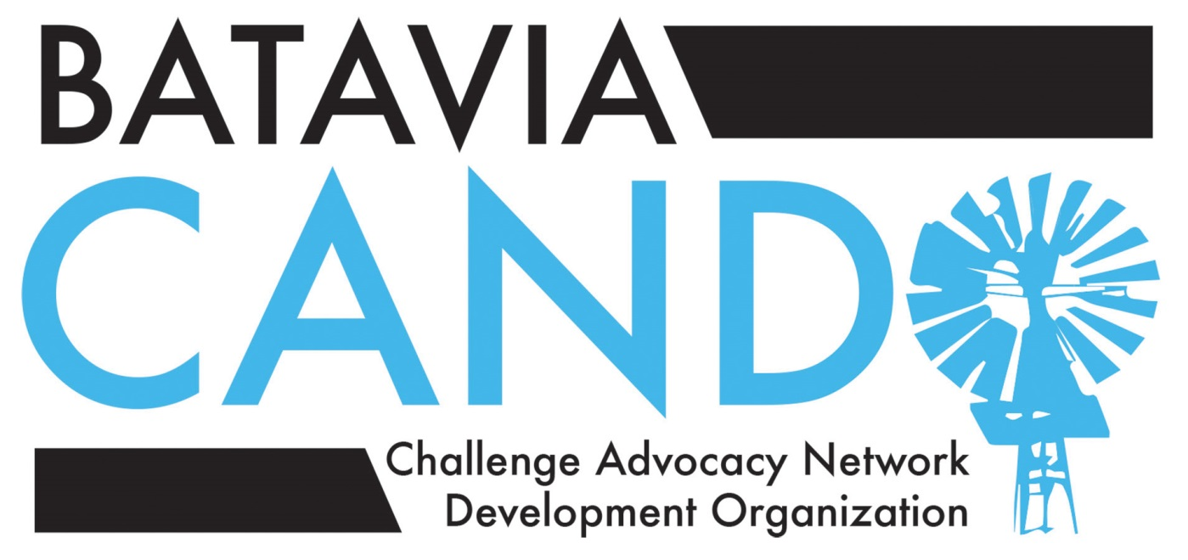
Notes from the May 11, 2015 Gifted Committee Meeting
Attendees: Dr. Brad Newkirk, BPS CAO; Dr. Kevin Skomer, LWS Principal; Mrs. Laurie Fiorenza, Vice-principal, Curriculum and Instruction, RMS; Mrs. Julie Allen, Dr. Pam Ciway, Miss Julie Preble, Gifted Coaches; Dr. Sue Sokolinski, third grade teacher at AGS; Mrs. Colleen Puttin, first grade teacher at LWS; Kyra Holzman, CANDO RMS Liaison; Norma Fortino, CANDO GMS Liaison; Heather DeBaun, CANDO JBN Liaison; Jessica Kelly, CANDO AGS Liaison; Nikki Rousseau, CANDO LWS Liaison; Christy Magerkurth, CANDO Advocacy Chair; Anna Adams, CANDO Programs Chair; Margie Goliak, CANDO 2E Resource Chair; Deb Grizzell, CANDO Chair
Agenda items for this meeting included:
- Review of progress: Gifted Services “Vision” Work Group
- Review of progress: Gifted Services “K-2” Work Group
- Update on changes to the process for identification/placement in Gifted Services at Rotolo Middle School
- Report of effectiveness of the “Collaboration Station” approach to gifted Mathematics instruction elementary level
- Increased STEM course offerings at all levels in BPS

Gifted Services “Vision” Work Group
Group members: Dr. Brad Newkirk; Dr. Laurie Fiorenza, RMS (unable to attend 1st meeting); Jennifer Hix, Divisional Coordinator, RMS; Nikki Rousseau (LWS); Dr. Sue Sokolinski, 3rd grade AGS; Jodie Pufundt (CANDO Secretary); Deb Grizzell (CANDO Chair); Christy Magerkurth (CANDO Advocacy Chair); Jessica Kelly (AGS)
Deb Grizzell described CANDO members’ on-line search of gifted services programs across the U.S. to inform our construction of a proposed vision statement for BPS Gifted Services. The resulting statement reflects the values CANDO work group members felt should be included in a statement of vision: 1) that the “whole child” be considered, including children’s emotional and social development, not just academic work; 2) that the vision statement would be inclusive of the whole population of gifted and high-ability students, including twice-exceptional students; 3) that the vision statement would reflect the “culture of excellence” Batavia seeks to cultivate in its schools.
The CANDO work group member-composed proposed vision statement reads:
Batavia Public School’s Gifted Services will challenge students to reach their full potential and prepare them to contribute to a complex global society by providing an environment of excellence that meets the distinct academic, social and emotional needs of gifted and high ability learners. (Also see attached “CANDO Notes on the Development of Vision Statement…” which were presented to the Gifted Committee at this meeting.)
Discussion of this proposed statement illustrated general consensus of the values represented in the statement. Dr. Newkirk suggested that the statement could be further refined, and other meeting participants suggested that the refined version of this statement be submitted to the gifted cluster teachers at the elementary and middle school, and to a representative from the high school, for their review and comment.
Some topics to be addressed in the upcoming meetings for this work group include:
- Clear definitions of terms (i.e. flexible grouping, differentiation, etc.)
- Equity in service delivery—“giving kids what they need, when they need it, across the district”
- Partnerships with parents and teachers
- Consistency across levels of education in the district and in transitions between levels (i.e. elementary to middle school)
- Best practices in instruction
- Professional development
- Articulation
- Identification procedures
- Motivation—further work to establish a “culture of excellence”
- Addressing the unique social and emotional needs of gifted and high-ability students
- Special needs and considerations for twice-exceptional learners
Next steps for the “Vision” Work Group include: 1) providing a refined version of the proposed vision statement and accompanying definitions of terms relevant to gifted services (i.e. “gifted”, “differentiation”, “enrichment”, etc.) and, 2) submitting them via on-line survey forum to gifted cluster teachers and representative(s) from BHS before the end of the school year for feedback from teacher participants in BPS Gifted Services. The resulting feedback will guide the efforts of the “Vision” Work Group during the summer. 3) Prioritizing the items from the above list of topics to be addressed. 4) Formulating a time line for work on the vision statement, philosophy and goals of Gifted Services, as well as revision of the Gifted Handbook to give structure to the efforts of the group and maintain momentum.
Dr. Newkirk indicated that revisions to the Gifted Handbook and changes in Gifted Services processes will not begin in the fall of 2015, but could be effective by the fall of 2016. Dr. Newkirk said contractual obligations with teachers would prohibit essential involvement by teachers in these revisions/changes during the summer months, thereby pushing any changes into the 2015-16 school year. CANDO participants offered to continue their participation in the work group during the summer months, and will proceed by working with Dr. Newkirk and a smaller writing sub-group of CANDO participants to define key terms and work on proposed goals for Gifted Services.

Gifted Services “K-2” Work Group
Group members: Dr. Kevin Skomer (Principal, LWS); Mrs. Colleen Puttin (1st grade teacher, LWS); Dr. Pam Ciway and Miss Julie Prebel (Gifted Coaches); Anna Adams (CANDO Programs Chair); Allison Lindy and Erika Mochal (AGS parents); Sara Simeunovic and Amanda Horne (LWS parents)
Dr. Kevin Skomer reviewed the progress made by the “K-2” Work Group. An “ideal solution” was proposed by the CANDO participants in the meeting (see attached “Gifted Services in the Primary Grades—Ideal Solution”). The proposed Philosophy statement to guide development of gifted services in grades K-2 is below:
PHILOSOPHY
The Batavia Public Schol District is committed to the academic success or all students. Our current mission statement, “Always learning. Always growing.” guides the district’s strategic plan to ensure that our focus is on the critical task of maximizing student growth. All students should be challenged at their highest level in all learning areas.
In order to ensure that early learners (grades K-2) are learning at their full potential, the BPS district is committed to identifying students who exhibit characteristics of high intellectual ability and to meeting their special learning needs. Academically or intellectually gifted students perform or show the potential to perform at substantially higher levels of accomplishment when compared with others their age. Academically or intellectually gifted students require differentiated services beyond those ordinarily provided by the regular education program. Outstanding abilities are present in students from all cultural groups, across all economic strata and in all areas of human endeavor. Children blossom and grow at varying rates; therefore, it is important to periodically reassess students to ensure the inclusion of students who would benefit from these services.
Batavia Public Schools is dedicated to providing gifted and potentially gifted students a rigorous and innovative instructional program that fosters the highest level of excellence and recognizes the right of each student to receive intellectual challenge appropriate for his/her capabilities. These learners have special intellectual, social, and emotional needs that require an enriched educational environment designed to develop superior thinking skills with curriculum that offers greater complexity, more depth, and a faster pace. Services will be designed to provide challenging instructional activities in math, reading, writing, problem-solving, and critical/creative thinking to students in grades K-2 who demonstrate gifted potential.
The work group made specific recommendations around early identification, service delivery, “guaranteed” services with consistency between all elementary buildings, and transparent communication. These are best understood by examining the group’s attached working document, but key points include:
- formal identification of students with gifted/high-ability potential, with efforts beginning as early as Kindergarten preview, and utilizing multiple modalities of data collection (including parent surveys and teacher recommendation)
- formal means of communicating students’ participation in enrichment/acceleration between grade levels
- multiple opportunities for identification/participation in grades K-2
- service provision by professional staff, with support provided by trained parent volunteers (fall PETS training for parent volunteers— see http://www.primaryeducationthinkingskills.com/-- by grade level, supervised by Gifted Coaches at a central location)
- service delivery via a combination of “pull-out” enrichment groups and differentiated instruction/assignments linked to grade level core curriculum (“instead of”, not additional work for gifted students)
- all students have access to similar learning experiences in all elementary schools across the district
- no “opt out” for teacher/school participation
- defined standards for identification and instruction
- parents are partners throughout the process, and communication is frequent and transparent
CANDO will post the document outlining the details of this proposal from the K-2 Work Group as soon as it is made available.

Changes to the identification and placement process for Gifted Services at Rotolo Middle School
Mrs. Laurie Fiorenza outlined changes effective immediately for participation in Gifted Services courses at Rotolo Middle School. Letters explaining these changes of procedure were sent electronically to all RMS parents May 12. For further information, visit the RMS website or contact Mrs. Fiorenza.
A brief summary of the changes:
The data used in the 5th grade student identification process were expanded to include all 4th grade and the Fall and Winter 5th grade MAP scores. Students qualifying based on MAP scores were given the CoGAT screener, completed a writing assessment and had teacher perception forms completed. 33 current 5th graders qualifies for both advanced Math and advanced English Language Arts (ELA) placement.
In addition, students were identified for placement in advanced Math or advanced ELA who did not qualify for placement in both. In order to ensure successful inclusion of all advanced students, the characteristics of the 33 students who qualified for both advanced courses were reviewed and used to set the threshold for placement. (The means that each year the threshold will be unique to the abilities of the specific cohort of students.) The lowest average MAP score for math and for reading was calculated, and teachers of students who met this requirement were asked to complete a teacher perception rating. These students were also given either a writing assessment or a five-question math screener (developed by the RMS Math Department), depending on which subject they qualified for. In this year’s 5th grade, the qualifying MAP cutoffs were a 92% national percentile for ELA, 94% for Math III and 75% for Math II.
This process resulted in the creation of three Advanced English Language Arts (ELA) class sections at RMS for next year’s 6th graders, and four Math III class sections.
Because the current 6th and 7th grade students had not had the opportunity to qualify for advancement in individual subjects, a similar process was used to evaluate all students for advanced placement next year. Students currently in advanced courses did not need to requalify, but the process described above was used to identify additional students that would benefit from increased rigor. Less additional testing was conducted, however, given that RMS teachers were already familiar with the students’ abilities and knowledge and could more easily make placement recommendations. This has resulted in a substantial increase in the number of advanced Math and ELA classes for next year’s 7th and 8th grade classes’ as well.
Collaboration Station report
The “Collaboration Station” is the instructional method proposed by CANDO earlier this year to address the instructional needs of next year’s (2015-16) cohort of gifted fifth grade students who will receive 6th grade-level Mathematics instruction. BPS will not hire instructors for daily Mathematics instruction for this group, so CANDO proposed having Gifted Coaches teach a section of gifted 5th grade Math students on-site when they are in the building, and simultaneously broadcast their classroom discussion to the gifted 5th grade Math students at the other building they serve. Thus, instruction would alternate between “live” and “remote (Collaboration Station)”. This ensures daily interaction with an instructor for this cohort of gifted Math students.
Dr. Newkirk reported some success with this mode of instruction as it has been piloted at HWS, with a few technological challenges that remain to be worked through before the Collaboration Station is in full use Fall 2015. For more information about the Collaboration Station, contact your school’s Gifted Coach.
Increased offerings in ST EM-subject courses at all levels in BPS
“Project Lead the Way” ( https://www.pltw.org/) is a series of courses in STEM subjects that are being offered at Rotolo Middle School. Further development of these courses and additional offerings will occur next year at RMS. BPS is also looking at piloting “Launch”, an after-school program for elementary students with interest in STEM subjects, next year. Mrs. Julie Preble can be contacted for more information about Launch. (https://www.pltw.org/our-programs/pltw-launch)

CANDO’s Executive Board continues to monitor our website, gmail account and Facebook page during the summer months. Members of the Executive Board and several of the Gifted Services Work Groups members will also continue their efforts in advocacy and development of gifted services in BPS while we’re all away from the classroom.
Please see the accompanying Work Group documents or refer to the BPS Gifted Services web page, the CANDO website and Facebook page for updates as you enjoy your summer.
Don’t forget the CANDO General Membership Meeting tomorrow night, May 21 at 7 pm in the LMC at Rotolo Middle School for a recap of our year, and a look into the future for CANDO and BPS Gifted Services. Thanks to all who have volunteered and contacted CANDO with feedback through this year. A special thanks to the CANDO 2014-15 Executive Board Members, all of who are willing to offer their service again next year, and to our dedicated group of CANDO School Liaisons. And thanks to all the dedicated BPS professional educators who provide challenging and engaging learning opportunities for Batavia’s gifted and high -ability students.
Enjoy your summer…and join us in August (date TBD) for the
annual CANDO-sponsored Back-to-school Picnic at Big Woods Park!

Warm regards,
Deb Grizzell
CANDO Chair

