30 November 2015 Gifted Committee Meeting Summary
Topic: “Vision” Work Group and Gifted Handbook Revision Process

Attendees from BPS
- Sue Sokolinski, PhD; 3rd grade cluster teacher, AGS; “Vision” Work Group participant
- Pam Ciway, PhD; Gifted Coach, AGS and LWS; “Vision” Work Group participant*
- Julie Prebble, Gifted Coach, HWS and JBN; K-2 Work Group participant
- Kevin Skomer, EdD; Principal, LWS and head of elementary Math curriculum development team; K-2 Work Group participant*
- Bob Dietz, Vice Principal, BHS over Curriculum and Instruction; “Vision” Work Group participant since Sept. 2015*
- Jennifer Hix, Vice Principal, RMS over Curriculum and Instruction; “Vision” Work Group participant*
- Colleen Puttin, 1st grade teacher, LWS; K-2 Work Group participant
- Brad Newkirk, EdD; Chief Academic Officer, BPS; “Vision” Work Group participant*
Attendees from CANDO
- Kimberly Lawler-Sagarin, CANDO 2E Resource co-Chair
- Norma Fortino, RMS School Liaison (6th grade rep)
- Jodie Pufundt, CANDO Secretary/Treasurer; “Vision” Work Group participant*
- Nikki Rousseau, LWS School Liaison; “Vision” Work Group participant
- Kyra Holzmann, RMS School Liaison
- Heidi LeRette-Kauffman, CANDO Resource Chair
- Spencer Pasero, HCS School co-Liaison; new “Vision” Work Group participant (since Nov. 2015)
- Amy Petersen, JBN School co-Liaison
- Jessica Kelly, Advocacy co-Chair; “Vision” Work Group participant
- Deb Grizzell, CANDO Chair; “Vision” Work Group participant*
*denotes member of “Vision” Work group sub-group for revision of Gifted Handbook
Also note: CANDO parents who participated in the K-2 Work Group included: Erika Mochal, now AGS co-Liaison; Anna Adams, CANDO Programs Chair; Allison Lindy, Amanda Horne, Sara Simuenovic. Additional CANDO member of the “Vision” Work Group and sub-group for revision of the Gifted Handbook is Christy Magerkurth, CANDO Advocacy co-Chair.
Discussion about process of “Vision” Work Group and Gifted Handbook Revision sub-group
Members of the Gifted Handbook Revision sub-group met twice this summer to create a “Vision” statement for BPS Gifted Services that more closely aligned with the newly-revised BPS Vision Statement and that would serve as a guiding statement from which core values, definitions, and processes related to identification, placement and service provision would be designed. The resulting Vision statement and Core Values are as follows, and can be found in the attached slides (slide 2) from the November 30 Gifted Committee meeting PowerPoint presentation created by Dr. Newkirk.
Batavia Public Schools services for high-ability students support the whole child, academically, socially, and emotionally. Personalized and flexible services include appropriate rigor and result in student engagement that fosters continuous growth and learning.
Core Values
· A culture that embraces a growth-mindset and allows for productive struggle is an essential component of the learning process.
· A supportive environment teaches communication, collaboration, and perseverance, fosters creative problem-solving, and sparks curiosity.
· All students are individuals with unique needs and thrive in an environment that recognizes and responds to their academic, social, and emotional needs.
· Student self-efficacy and advocacy are fundamental skills that must be developed and supported through the learning process.
· Purposeful assessments support the growth of students through high-quality feedback, self-reflection, and student ownership of the learning process.
· Collaboration and two-way communication are essential to the success of the learning community and is inclusive of parents, teachers, students, and the community.

Note: In addition to the “Vision” Statement and Core Values, Dr. Newkirk created a draft revision of the Gifted Handbook that included definitions of key terms and began to describe procedures for identification, placement and service provision. This portion of the Gifted Handbook revision was not presented at this Gifted Committee meeting, and therefore was not discussed.
At the November 19th meeting of the Gifted Handbook Revision sub-group, CANDO learned that the designation/term “Gifted” will no longer be used in BPS. Instead, all students scoring in the 90th percentile or higher on MAP scores will be designated “High-ability” students. Service provision at the elementary and middle school level will be offered to this group of students as a whole group. The exception will be this year’s cluster of gifted 5th grade Math students (who are studying 6th grade Math via the Collaboration Station teaching mode, and who will move into Math III as 6th graders at RMS. This cohort is the last group of gifted Math students BPS will continue to teach as accelerated Math students.) Information about CANDO’s reaction to this change in identification, placement and process can be found on the CANDO website in the November 19 Gifted Handbook Revision sub-group meeting summary submitted by Christy Magerkurth, CANDO Advocacy co-Chair and “Vision” Work Group participant.

Gifted and high-ability students (students scoring in the 90th percentile and above on MAP testing) will still be clustered at the elementary and placed in Honors middle school courses as outlined in the information below (from Dr. Newkirk’s PowerPoint):

5th to 6th Grade Placement Process 2016-2017
Current 5th graders in 6th grade math will go into Math 3 in 6th grade
Math 2/Honors ELA MAP data points
4th grade Fall,
4th grade Winter,
4th grade Spring,
5th grade Fall,
5th grade Winter
4 out of 5 in 80th percentile or higher will go into Math 2
4 out of 5 in 90th percentile or higher in Reading will go into Honors ELA

Discussion on this slide revealed that 3rd and 4th grade gifted and high-ability Math students (MAP scores 90th percentile or above) will received “Enrichment” materials in Math, but no acceleration or curriculum compacting in Mathematics will occur until students enter 5th grade.

Note: CANDO asked about student readiness for Math III at the middle school level if accelerated and compacted curriculum at the 3rd/4th grade level is discontinued. Dr. Skomer responded that the necessary curriculum compaction and faster-paced instruction to achieve placement in Math III will now occur entirely in 5th grade, under the direction/instruction of the regular classroom teacher in the context of guided Math groups.

Under this new service provision model, instruction for gifted and high-ability English Language Arts (ELA) students at the elementary level will be at the discretion/instruction of the regular classroom teacher. Classroom teachers will choose from several supplementary curriculum Enrichment options to provide additional rigor for gifted and high-ability elementary ELA students.
Gifted Coaches will no longer “pull-out” students to participate in Enriched ELA learning opportunities. Gifted Coaches will function as Instructional Coaches going forward, and will no longer have contact with high-ability students. They will instead interact with teachers as coaches when individual teachers request their assistance in problem-solving.
Information Dr. Newkirk’s PowerPoint about the possible Enrichment options from which primary grade level classroom teachers and elementary cluster teachers can select Enriched ELA lesson materials is seen below:
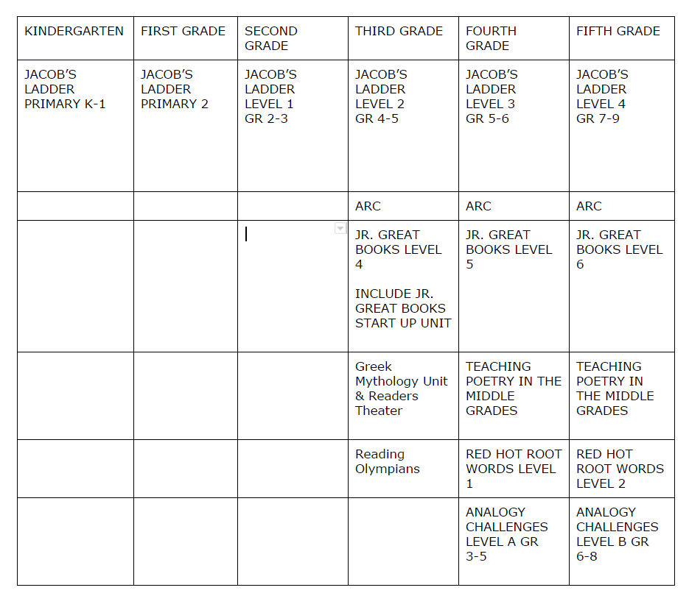

Note: CANDO expressed concern that under this new service provision model, cluster teachers can choose to “opt out” of offering Enrichment in ELA, and that participation in Enriched ELA opportunities will again become teacher-dependent and not unilaterally/equitably offered to gifted/high-ability students in all BPS elementary schools. Dr. Skomer responded that Building-level Intervention Teams (BLIT) will meet regularly to identify and properly place high-ability students in Enriched ELA learning opportunities and that Professional Learning Community (PLC) teams will discuss strategies for differentiation and enrichment.

Discussion of Elementary Math by Kevin Skomer, EdD
BPS is in the 2nd year of the roll-out of Common Core aligned Math curriculum and instruction. Math curriculum leadership teams have been working this past year to develop a pacing guide for use by all BPS elementary school teachers, because in year one of instruction using Common Core standards to guide curriculum and instruction practices it was determined that most teachers moved too slowly through lesson materials and did not complete the year’s required study of Math skills. This has resulted in district-level guidance on pacing and changes to the progress report for typical learners. Examining pacing at the district level in this way for high-ability students has just begun, and pacing guides are still 1-2 years away from roll-out for cluster teachers at the elementary level.
Two weeks ago, one grade-level representative from each school met at a district-level meeting to discuss Math curriculum, including assessment and pacing. This group will meet again in January and at the year’s end.
This district-level Math curriculum and instruction leadership team is planning to develop “Extension Units” for each Math unit in grades 3, 4 and 5; which can be offered to gifted and high-ability students identified by BLIT/PLC teams.

Note: It is unclear whether curriculum compacting will occur at only the 5th grade level, or whether it may additionally occur at the 4th grade level, as Dr. Skomer made mention of curriculum compacting at both grade levels in his comments. The information presented by Dr. Newkirk in his PowerPoint stated that curriculum compacting in Mathematics will only occur at the 5th grade level.

Discussion about identification and placement
Use of the CogAT will be discontinued at all levels in BPS. It was formerly offered as a screening tool to rising 3rd and 6th graders. BPS felt that with all of the testing required for students (MAP, PARC and BPS-designed assessments), no additional testing should be undertaken in identifying gifted/high-ability students.

Note: CANDO asked for clarification of the identification and placement process at the high school level. Mr. Diets initially confirmed that only MAP scores would be used to place incoming Freshmen students in Honors and AP courses. He then stated that MAP scores would be paired with teacher evaluation and previous course performance (grades). When asked to further clarify, he said that only MAP scores would be used, unless there was an appeal process initiated by students and/or their parents. Then BHS Department Chairs would review teacher recommendations and prior course performance data (grades) to make final decisions regarding placement.
CANDO then sought further clarification from RMS about identification/placement for Honors courses at the middle school level. Mrs. Hix explained that only MAP scores will be used for identification/placement. The appeals process, if initiated by parents, consists of students completing an RMS Math Department-designed five –item math assessment whose score determines placement in Math II or III, and/or an RMS ELA Department-designed writing sample assessment to determine placement in regular or Honors ELA. There is not a teacher recommendation component in the RMS appeals process.

Mrs. Hix further added that PLC teams for grades 6-12 meet regularly to discuss differentiation in the classroom.

General discussion
Dr. Newkirk stated that BPS is working to develop better “Institutional Memory”, so that more qualitative data about individual students learning styles, strengths and needs “follows students from one grade to the next”.
Dr. Sokolinski stated that as a classroom teacher (she was the only regular classroom teacher present at this point in the meeting, as Mrs. Puttin had to leave the meeting early to attend to other commitments) she would appreciate receiving a “checklist” or other inventory that summarized students’ learning styles, particularly containing information that highlighted traits shown in the professional body of research to be associated with gifted learners. Such information would allow her to begin the school year with understanding of student’s potential and learning styles, and facilitate differentiation in instruction from the very beginning of the school year, versus her spending the first couple months of the year trying to discover that information about her students.
Dr. Sokolinski also stated that she frequently utilized Dr. Ciway, the Gifted Coach at her school, to strategize instructional techniques and as a resource for learning materials for gifted students. Sokoliniski felt Dr. Ciway’s interaction with her students enabled her to give helpful insights and support that would be lost if Gifted Coaches no longer interacted with students.
Sokolinski also asked for clarification about whether students would still be “clustered” at the elementary level. Dr. Newkirk responded that they would, but did not clarify how they would be clustered (i.e. all “high-ability” students, or only those students who were formerly designated “gifted”).

Discussion about the Collaboration Station
Dr. Newkirk wanted to “highlight a success” of the collaboration between BPS and CANDO in the use of the Collaboration Station for gifted 5th grade Mathematics students this year. The Collaboration Station idea was generated by CANDO parents in a January 2015 CANDO Focus Group discussing Math instruction for Gifted Math students. All meeting attendees who are participants (or whose children participate) in the Collaboration Station process expressed only positive experiences with it. Dr. Newkirk invited Julie Preble to discuss the effectiveness of this tool, and Dr. Skomer added his praise of the Gifted Coaches thoughtfulness/professionalism and foresight in developing the processes and procedures required for successful use of this mode of instruction.
CANDO expressed mutual admiration of the Collaboration Station mode of instruction, and also expressed regret that this is a one-year-only experience. Since gifted elementary Math students are no longer going to receive accelerated instruction after this year, students will no longer utilize the Collaboration Station for Math instruction. And since regular classroom teachers will be providing Enriched ELA instruction under the new model of service delivery for gifted/high-ability students, there will be no inter-school collaboration in that area of study via the Collaboration Station either.
Dr. Newkirk said that BPS has begun using the Collaboration Stations for grade-level meetings of teachers across the district and will continue to use the Stations for those meetings and other teacher meetings.
Dr. Sokolinski suggested that Collaboration Stations could be used by elementary-level cluster teachers for district-wide collaboration meetings to share resources and problem-solve challenges. CANDO reminded the group that this process had been requested/suggested by CANDO in past Gifted Committee and Work Group meetings. Dr. Newkirk stated that this might be a possible use of Collaboration Stations in the future.

Areas for future focus/efforts by BPS
Dr. Newkirk identified the following:
- Ensuring that holistic data on each student is obtained and utilized in decision-making by BLIT/PLC teams. This would be a BPS-designed tool.
- Professional development that would prepare regular classroom teachers to take on the responsibility of differentiating instruction for “high-ability” students.
- Clarification of the appeals process for identification/placement decisions at RMS and BHS.
- Obtaining feedback from teachers about the new processes and services for “high-abliity” students K-12.
- Developing tools to measure consistency in service delivery.

Note: Several CANDO Board members expressed their concerns about gifted “going away”. Among their concerns:
- 2E students will be under-identified for participation in Enrichment and/or Honors learning opportunities by the use of only MAP data
- Discontinuing the identification of students the larger educational community (outside Batavia) designates as “gifted” will mean that these learners’ unique characteristics and approach to learning will go unserved under the new “high-ability model” of service delivery.
- Losing Gifted Coaches in a direct-service position with students will be experienced as a real loss, both to students and classroom teachers. Currently, gifted learners look forward to their pull-out time with Gifted Coaches as the only consistently engaging, challenging portion of their school experience.
- BPS will be returning to the teacher-dependent model of service delivery that delivered inequitable services and under-identified gifted and high-ability learners through the use of only MAP scores as identification criteria. This approach is not supported in the professional body of research as a best practice in education, nor is it a model in use by “Benchmark Districts” in communities surrounding Batavia.

CANDO thanked Dr. Newkirk and other BPS participants for their continued engagement in the process of developing a Handbook for reference by parents of gifted/high-ability students. Deb Grizzell commented that she attempted to create a document describing BPS gifted services processes and services over the past decade. She was unable to compile this information for today’s meeting, largely because very little written information on procedures and service provision exists. She suggested this highlights the need for a Handbook that contains current information, regardless of whether or not CANDO agrees with the procedures and processes adopted by BPS.
CANDO also reminded the Committee of the request to invite regular classroom teachers to participate in future Gifted Committee leaders, and stated that CANDO will actively seek feedback from teachers on the proposed changes to processes and service delivery, and will contact Amy Biancheri, president of the Batavia Education Association to solicit their support of teacher participation in future Gifted Committee meetings, and discussion of this topic in particular.
CANDO will provide this summary, as well as the slides from the PowerPoint presented by Dr. Newkirk, to Gifted Committee members by direct e-mail, and to CANDO parents via our website.

