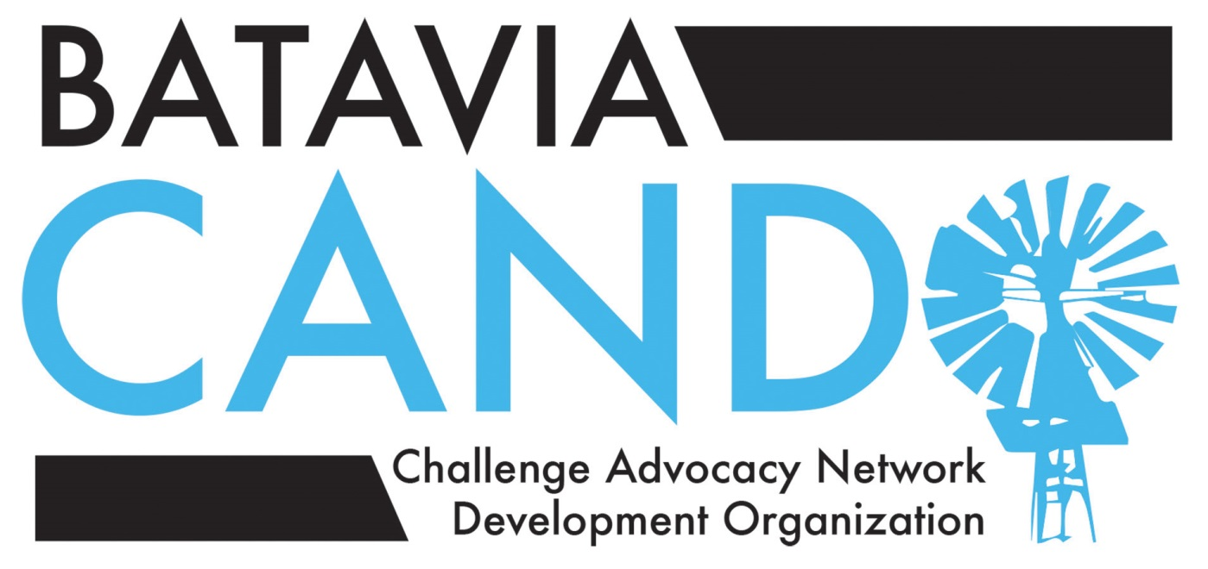
Proposed Ballot for the 2015-16 CANDO Executive Board
CANDO Chair Deb Grizzell
Advocacy co-Chairs Christy Magerkurth and Jessica Kelly
Programs co-Chairs Anna Adams and Heather DeBaun
Resource Chair Heidi LeRette-Kaufmann
Twice-exceptional (2E) Resource Chair Margie Goliak and Kimberly Lawler-Sagarin
Secretary/Treasurer Jodie Pufundt

CANDO School Liaisons
These positions are appointed positions, not subject to the May 21 election, but we encourage interested volunteers to submit their names and contact information by e-mail by May 20: bataviacando@gmail.com.

Alice Gustafson School open
Grace McWayne School open
H C Storm School Eileen and Spencer Pasero

CANDO School Liaisons (continued)

Hoover Wood School open
J B Nelson School Amy Petersen and Heather DeBaun
Louise White School Nikki Rousseau
Rotolo Middle School Norma Fortino (6th grade)
Colleen Nyland (6th grade)
Kyra Holzman (7th grade
open (7th grade)
open (8th grade)
open (8th grade)

