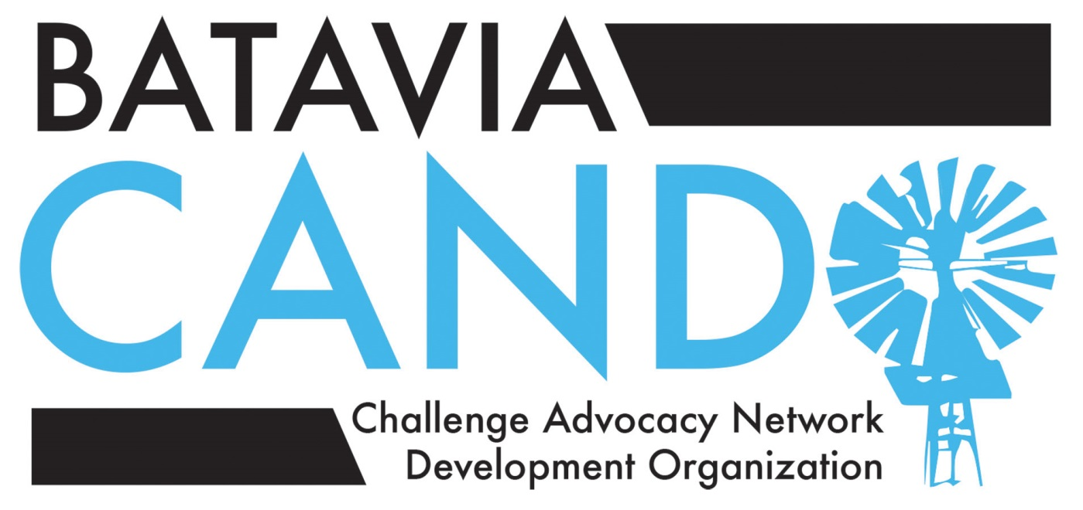
February 24, 2015
Letter of support for Batavia Public Schools’ participation
in the John C. Dunham STEM Partnership School

Esteemed members of the Batavia Public Schools’ Board of Education,

As you may be aware, CANDO is a Batavia volunteer-led organization for families of gifted and high-ability students in our community. We advocate for and support the interests of 600+ gifted and high-ability students and their families in BPS 101. Recently, like you, we became aware of the opportunity BPS101 has to participate in the John C. Dunham STEM Partnership School.

This letter serves as an endorsement from CANDO for Batavia Public Schools’ participation in the John C. Dunham STEM Partnership School. We believe students and teachers who are selected for participation in this extraordinary learning opportunity at nearby Aurora University will benefit personally, and will enrich the experience of their fellow learners and educators when they return to Batavia Public Schools by sharing the knowledge and experiences they acquired while attending the STEM Partnership School.

Please vote to join our neighboring districts in their participation at the John C. Dunham STEM Partnership School at Aurora University and provide any needed support to enable our district’s full participation in this unique educational opportunity.

Sincerely,

The 2014-15 CANDO Executive Board and School Liaisons

